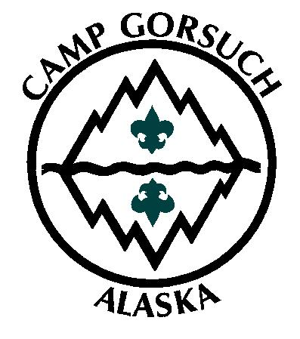
Leaders Guide
Camp
Gorsuch

2007

Great Alaska Council, Boy Scouts of America

CONTENTS

2007 CAMP GORSUCH LEADERS’ GUIDE
 |  |  | Page
Greetings From the Camp Director………………………….……………………………………………………. |  |  |  |  |  | 2
Introduction to Camp & General Information ………………………………………………………………..… |  |  |  |  |  | 3-4
 | Location of Camp | Visitors
 | Leadership | Transportation/Arrival/Departure
 | Basic Leader Training | Adult work weekend
 | Adult certification courses | Statement of Non-discrimination
Camp Fees…………………………………………………………………………………………………………… |  |  |  |  |  | 5
 | Weeks of Camp | Camperships
 | Camp Sign-up | Leaders’ Fees
 | Campsites | Craft Projects
 | Payment Schedule | Refund Policy
Health Services……………………………………………………………………………………………………… |  |  |  |  |  | 6
Wildlife Safety………………………………………………………………………………………………………. |  |  |  |  |  | 7
Food Service………………………………………………………………………………………………………… |  |  |  |  |  | 8
Your Role……………………………………………………………………………………………………………. |  |  |  |  |  | 9
Troop and Patrol Equipment………………………………………………………………………………………. |  |  |  |  |  | 10
Campers’ Equipment Checklist…………………………………………………………………………………… |  |  |  |  |  | 11
Information for Parents…………………………………………………………………………………………… |  |  |  |  |  | 12
Our Camp Law and Uniforming…………………………………….……………………………………………. |  |  |  |  |  | 13
Time Table………………………………………………………………………..………………………………… |  |  |  |  |  | 14
Experience Tells Us………………………………………………………………………………………………… |  |  |  |  |  | 15
Upon Your Arrival…………………………………………………………………………………………………. |  |  |  |  |  | 16
Program Features and Planning
 | Program Opportunities and Ideas……………………………………………………………...………… |  |  | 17-18
 | Cheechako Trail………………………………………………………………………………...…………… |  |  |  |  | 19
 | Merit Badge Information………………………………………………………………………………… |  |  | 20-22
 | Bear Claw Award……………………………………………………………………………………………. |  |  |  |  | 23
 | Silver Sourdough Program………………………………………………………………………..………… |  |  |  |  | 24
 | Scoutmaster Events……………………………………………………………………………..….……….. |  |  |  |  | 25
 | Troop Program Planner……………………………………………………………………………………… |  |  |  |  | 27
Troop Roster………………………………………………………………………………………………..……… |  |  |  |  | 28
Biking Information………………………………………………………………………………………………… |  |  |  |  | 29
Camp Gorsuch Map………………………………………………………………………………………...……… |  |  |  |  | 30

This camping opportunity is made available through the Great Alaska Council, Boy Scouts of America. Camp Gorsuch meets the standards of the National Council, BSA and is inspected to assure you a high quality, successful camping experience. | This publication was made possible through the generous support of the Nanuk Lodge 355, Order of the Arrow whose contribution to Camp Gorsuch is immeasurable and on going. Thank you Nanuk Lodge for your hard work and dedication to this camp.

GREETINGS

WELCOME TO CAMP GORSUCH!! For one week this summer your unit will experience all of what Alaska and Scouting have to offer. It doesn’t matter if you are a veteran of many summers at Camp Gorsuch, or if this is your first summer, each week at Camp Gorsuch has its own set of unique memories. In order to prepare you for the upcoming adventure we are providing you with this leaders guide so your Troop can Be Prepared for the upcoming experience.
In planning for your upcoming camp experience there are a few steps you can take in ensuring your unit has a great week at Camp Gorsuch. First, make sure you know the ability and advancement level of each Scout. Knowing what each scouts rank and the requirements needed for advancement will allow you to place them into the camp program that will be most beneficial to them. Secondly, have your Troop’s patrols organized before they come to camp. The patrol method is the way we operate at Camp Gorsuch. In addition to preparing the evening meals in camp sites, patrols participate in a variety of activities together such as rifle shoots and service projects. Having strong patrols that function well together will ensure a great experiences and memories. Finally, familiarize your self with all the camp awards and programs, such as the Bear Claw award and the Silver Sourdough program for your older scouts.
For those of you whom this is your first time at Camp Gorsuch please familiarize yourself with the open program at Camp Gorsuch, it is explained later in the manual but if you have question feel free to contact us. In addition we are adding to different programs here at Camp Gorsuch, so make sure that even you “Gorsuch veterans” take a look at the complete leaders guide.
We also encourage you to make sure that you and your other leaders take advantage of the multiple of training opportunities we provide during the week for adult leaders at Camp Gorsuch. In addition to leader roundtables and adult certifications we provide, Camp is an excellent time for you to interact with Scouting leaders from other units sharing information amongst you.
Finally, remember that Two Deep Leadership is required throughout your week at camp and while it may not be possible for both leaders to be there for the whole week, it can make a big difference in your Troop’s camp experience if at least one leader is able to stay at camp for the whole week.

We are putting together an excellent staff to deliver your unit an excellent program and we look forward to hosting your Troop for an excellent week of camp.

Yours in Scouting,

Keith E. Messer
Camp Director
INTRODUCTION to CAMP

CAMP GORSUCH is located halfway between Anchorage and the Matanuska Valley (25 miles from each). It is situated on Mirror Lake in the shadow of Bear Mountain and is adjacent to 1400 acres of parkland.
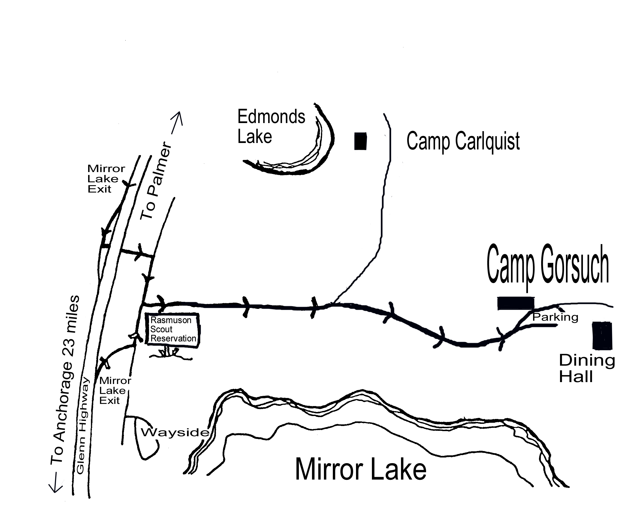

ADDRESS
Camp Gorsuch
22700 Camp Gorsuch Road
Chugiak, Alaska 99567
Tel (907) 688-9536
FAX (907) 688-9537
CAMP OPERATED BY:
Great Alaska Council
3117 Patterson Street
Anchorage, Alaska 99504
Tel. (907) 337-9547
FAX (907) 338-6273

Owned by the Boy Scouts of America, Great Alaska Council, the camp was given to the Scouts by an "Act of Congress" in 1955. Since that time many dollars and many Scout hours have been spent for road development, building, pipelines, waterfront reclamation, and other necessary camp development and maintenance projects.

Today the camp offers a beautiful lake, Scout Skills program areas, and nature and adventure trails throughout the camp. You can create your own meditation grove, visit a waterfall, climb a mountain, go fishing in the lake, or listen to the wonders of nature. Camp Gorsuch is your camp to enjoy and appreciate. Many in-camp imaginative adventures await discovery by Scouts and leaders alike as they share this unique natural environment.

“Scouting promises you the great outdoors.” That is the first sentence in the Boy Scout Handbook. Camp Gorsuch summer camp can be a part of fulfilling that promise. With its programs and activities, Camp Gorsuch will do its best to bring meaningful adventure to the lives of those who attend. The staff of Camp Gorsuch is looking forward to helping you, the adult leader; make positive changes in your Scouts. Let’s work together and change the world this summer.

Before you go to camp, certain promotional and informational data should be shared with the Scouts and parents in your unit. This can take place in many ways and forms. The basic reason for this kind of activity is to keep everyone informed, excited, and prepared for the week ahead. Boys need to know what to bring, what activities to prepare for, and what merit badges are offered. Patrols need to get flags ready and sharpen certain skills for the "Be Prepared Relay". Troop leaders need to remember the advancement and activity goals set by their Patrol Leaders' Council and plan their participation accordingly. Parents need to know how much camp costs, when it will be, where it is, and how to send mail. Scoutmasters need to know all this and a lot more.
Many troops hold a PARENT INFORMATION MEETING a few weeks before camp. This meeting can take place at a Court of Honor, a committee meeting, in place of a troop meeting, or at any other convenient time. It is here that the details of camp are presented to the parents for their information. Questions and answers take a majority of the program. Don't expect to have all the answers, but assure the parents that a reply can be found either from this guide or through the Council Service Center.

TROOP LEADERSHIP
The person in charge of your troop must be at least twenty-one (21) years of age; there are no exceptions. In addition, it is the policy of the Boy Scouts of America that, "trips and outings may never be led by only one adult. At least two adult leaders, one of whom must be 21 years or older, are required for all trips and outings." The result is more fun for the adults and a better program for the Scouts. Troop leadership will verify all “no shows” to see why a Scout can not come to camp on the first day.

BASIC LEADER TRAINING The “Introduction to Outdoor Leader Skills” section of Basic Leader Training will be available, if needed, every week of camp. The training will be held at Dan’s Palace,, Tuesday through Friday, from 9:30 AM until lunch.

ADULT TRAINING OPPORTUNITIES An hour long certification course is offered every day at 1:15 PM Tuesday through Friday. (Safe Swim and Safety Afloat, Youth Protection, Climb-on Safely, and Trek Safely) Troop leaders who are not spending the week at Camp Gorsuch are also invited to attend.

VISITORS Parents are always welcome to visit camp. Please, no pets! All visitors must sign-in at the camp office and receive a visitor wrist band. Whenever a camper (youth or adult) departs camp he or she must sign-out in the same book, and then sign back in upon return. In the case of youth, he must be signed out by an adult with the knowledge and concurrence of the unit leader. We ask that parents inform unit leaders of any special permissions or restrictions concerning any persons with whom their child may leave camp.

TRANSPORTATION, ARRIVAL AND DEPARTURE Transportation to camp is to be furnished by the troop. Bike routes and a map are in the back of this guide. Troops should arrive between 8:30 - 9:30 AM Monday. Troops that arrive late often miss the Monday morning Leaders' Roundtable (10:45 AM). Departure time is after the Saturday night campfire (about 8:00 PM). If your troop must leave earlier for travel or other reasons, please advise the Camp Director so that your troop advancement paperwork can be made ready for you.

ADULT WORK PARTY On May 12th we will have a council-wide work party at Camp Gorsuch. There's a lot to do so put on your work clothes and gloves and spend the day with your Scouter friends fixing what needs fixing and building what needs built. Lunch will be provided, so Y'all come! Be there. This is the only way we can get camp ready.

LEADER ORIENTATION There will be a camp leader orientation meeting on Tuesday, May 29th at 7:00 PM at Camp Gorsuch. This orientation will prepare you for a successful camp. You may also pick up your free camp T-shirts (see page 6).

STATEMENT OF NON-DISCRIMINATION No person will, on the grounds of race, color or national origin, gender, or handicap be excluded from participation in, be denied the benefits of, or be subject to discrimination under any program or activity of the Great Alaska Council, Boy Scouts of America.

CAMPSITES | PATROL SITES | MIN/MAX SCOUTS | CAMPSITE | PATROL SITES | MIN/MAX SCOUTS
TAZLINA | 2 | 10/18 | DENALI | 3 | 18/26
SPURR | 2 | 10/18 | KODIAK | 3 | 18/26
UPPER PTARMIGAN | 2 | 10/18 | LOWER PTARMIGAN | 3 | 18/26
YUKON | 2 | 10/18 | BEAR | 3 | 18/26
BELUGA | 2 | 10/18

CONFIRMATIONS All campsite requests and all payments will be acknowledged by receipt. (Please keep your receipts) Any troop falling behind in the fee payment schedule as prescribed in the camp sign up brochure is considered to have relinquished their claim to that campsite.

CAMPERSHIPS Camperships are available to assist a Scout when financial circumstances indicate a need. Applications are available at the Rasmuson Service Center. All information will be held in strict confidence. Early submission of applications is most important. Camperships are non-transferable.

LEADERS’ FEES One adult leader is free and another leader is free with each 10 paid Scouts. Additional leaders will pay a $85 fee to cover the cost of the food except:
If 20-29 campers. 3 leaders free
If 30-39 campers 4 leaders free
If 40-49 campers. 5 leaders free

CRAFT PROJECTS Most craft projects, including projects for Indian Lore, Leatherwork, Basketry, Pottery, and Woodcarving merit badges, have an additional charge of $8.00 to cover the cost of materials.

REFUND POLICY Camp deposits due on December 1st are non-refundable. If a boy does not come to camp due to a non emergency then 50% of the camp fee is refundable. If a boy does not come to camp due to situations out of his control, a larger refund may be available.
HEALTH SERVICES

All Scouts and adult leaders camping at Camp Gorsuch must have a completed Boy Scouts of America physical examination form on file at the Health Lodge. Adults over 40 years of age must have a physical examination each year and use the Personal Health and Medical Record Form Class 3 (No. 34412). Scouts and adults under 40 use the Class 2 physical examination form (No. 34414). If a Scout or adult under the age of 40 has had a physical examination within the last 36 months they can attach a copy of that physical to a new No. 34414 and only need to complete the Class 1 Personal Health and Medical History portion. All physical forms for minors must be signed by the parent or guardian. Adults must sign their own physical. Physical forms will be returned to the unit leader at Dan's Palace Saturday at the picnic.
A copy of the physical forms is included with this guide. Physical forms are also available at the Rasmuson Scout Service Center, 3117 Patterson Street, Anchorage, Alaska 99504 (phone (907) 337-9547).
WE STRONGLY RECOMMEND that all physical forms be collected by the troop's adult leader two weeks prior to camp. This will insure that all Scouts and leaders have a properly completed form. Finding out something is missing upon your arrival at camp is a headache that should be avoided. NO ONE WILL BE ALLOWED TO STAY AT CAMP WITHOUT A PHYSICAL. All participants need to be covered by insurance by the unit or through their family medical coverage. The insurance policy number must be noted on every person’s medical history form.
There is no charge for first aid performed in camp for Scouts and leaders. All campers needing services performed in town at the hospital or clinic will be covered by their unit insurance or their family insurance. In case of an accident that requires “in town” services, the medical history form including the insurance policy number will accompany the injured person.
Please read the explanation of storage and administration of medications on the "Information For Parents" page.
WILDLIFE SAFETY

We believe that bears have as much right to live in Alaska as we do and that seeing bears in the wild is a wonderful experience. However, we realize that as a council we have a risk of a bear encounter so the Western Alaska Council has developed a set of rules and guidelines that will be followed in order to maximize the safety of our Scouts and leaders during their outings. The following is an outline of what to do if a bear encounter is experienced at camp.

{If you see a bear, do not panic! Do not Run! Make lots of noise.
{Learn to recognize the evidence of a bear’s presence.
{Always use the Buddy System!!
{Notify staff of bear sightings.
{Bears do not like surprises. Make lots of noise while walking trails.
{Do not crowd bears! Give them plenty of room.
{Bears are always looking for something to eat. Bears are attracted to all
smells. Keep all smell able items in the bear box. (This includes foods, snacks,
soap, shampoo, toothpaste) Suggestion: Pack your personal items in a small bag with your name for easy access and organization.
{Get things out of the bear box, close the lid. Do not leave the bear box open.
{Keep your camp clean at all times.
{Do not burn food garbage. When there is incomplete incineration – smells remain.
{When cleaning up dishes, scrape garbage into trash bag.
{Dump wastewater into the latrine.
{Haul all trash to the dumpster after each meal.
{Only use established toilets or latrines.
Special note: Most bears in camp are black bears and the old adage to roll up in a ball on the ground and play dead is the wrong thing to do with black bears. Black bears are more non-confrontational and do not like to be attacked. If they are exhibiting predatory behaviors, the thing to do is attack them with noise, a club, bean bags, crackers, etc. This is why it is so important to let the Camp Gorsuch staff know right away if there is a bear(s) in camp. They are trained to take these actions. Chances of getting a brown bear in camp are pretty low. Bear ID is important.

LEADERS
Your first responsibility is the safety of your Scouts. Camp is a great opportunity to set good camping habits. Bear safety training is now required in the Western Alaska Council. Details about council bear policy are available at camp. Bear safety videos are available at camp. Further information can be obtained from the Alaska Department of Fish and Game.
FOOD SERVICE

DINING HALL One of the outstanding features of Camp Gorsuch is our dining hall feeding. Expert cooks are employed to prepare hearty meals that are served family-style. Full uniform is expected at the Monday and Saturday dinners and, in general, Scouts should be clean, wearing appropriate shirt and pants (not swimming trunks) at all meals.

Breakfast: Monday dinner:
Waiters 7:50 a.m. Waiters 5:50 p.m.
Campers 8:00 a.m. Campers 6:00 p.m.
Lunch: Saturday picnic:
Waiters 11:50 a.m. Campers 5:00 p.m.
Campers 12:00 noon

IMPORTANT
Scouts who have dietary restrictions may request substitutes by notifying the
Camp Director by Wednesday of the week prior to your coming to camp.

For each meal, the dining hall steward is supported by troop members. Each table will assign Scouts to be waiters. These Scouts will participate in the setting of the tables, serving the food, and cleaning up at each meal. These assignments will be made on Monday.

PATROL COOKING Patrols will be responsible for cooking their own meals on Tuesday, Wednesday, Thursday, and Friday evenings. All food is picked up at 5:00 p.m., packaged one meal at a time, from the Commissary window. Each patrol will receive their food supplies to be prepared in the campsite.

OFFICIAL NOTICE In compliance with Municipality of Anchorage Department of Health regulations and the National Standards of the Boy Scouts of America, the storage of perishable foods in the campsites are not allowed. This includes all dairy products and meat. This regulation is intended to protect the health and safety of campers. The menus and deliveries are designed so as not to require long term perishable food storage. Eat all food or dispose of it and let your commissary know if you are receiving too much of any food item so waste can be avoided. Removing garbage from your campsite is also a way of discouraging BEAR visits. (see Wildlife Safety page 8)

VISITOR MEALS Visitors can purchase a meal at the Camp Office. Please let your Scoutmaster make arrangements through the Camp Director ahead of time. There may be a limit to the number of visitor meals available for any one meal due to the seating capacity of the dining hall.
YOUR ROLE

Camp Gorsuch is a beautiful Scout facility and has a large variety of program opportunities available. You are encouraged to use these resources to best meet the needs of your troop.

THE CAMP STAFF Another resource that is available to help your troop is the camp staff. The staff is there to help your troop in a number of capacities. Their main goal is to help YOU help your troop meet its goals.
Your troop at camp is under the leadership of your Scoutmaster. The camp staff can help Scoutmasters in a number of ways. They have had intensive training, know the area, have knowledge in Scout skills, are trained in specialized areas like archery, riflery and safe waterfront practices, and have hundreds of ideas. They love what they are doing, so don't be afraid to ask them anything.
With the camp staff available and handling a number of programs, what is the role of the troop leaders?
It is not the staff's intent or role to take over the operation of your troop. Their support, though, should give leaders time to devote to their real task at camp - boy development.

A BOY'S DEVELOPMENT A boy's development generally happens two ways at camp; as an individual and as a part of a group.

As an individual, he will be learning through merit badge work, challenging himself in activities like the mile swim and rappelling, and building self confidence through the accomplishment of goals. Your role as a leader will be to give him guidance as he chooses his merit badges, encouragement as he tries new things, motivation to keep him on schedule with his goals, and understanding and counsel if things aren't going right.

As a part of a group, his patrol and troop, he will learn responsibility, cooperation and leadership. That's a lot to ask of a young boy, but it is also why Scout camp is such a good experience. Your role as leader will be to help the PATROL METHOD work. Don't shortcut it; you will only be cutting out boy development.
Work through your Patrol Leaders’ Council to make and carry out plans. Activities planned and carried out by boy leaders, with guidance, are usually enjoyed by all patrol and troop members. Help your Patrol Leaders to get their patrols working smoothly. They can do it, but they need some advice.
Good luck. Boy development may be challenging, but it will also be rewarding.

EQUIPMENT

The Camp will furnish all troops with tentage for their stay unless the troop brings more Scouts or adults than the site will handle. Health and safety standards dictate no more than 2 persons per tent. Each troop site is equipped with a “Bear Box”, patrol boxes, shovel, rake, broom and saw. There is a wood/charcoal burning pedestal grill in each patrol site. There is also a fuel locker at each site for troops that bring their own gas stoves (which can be a convenient back-up to the planned cooking over a fire). Each troop site has a latrine, a campfire area and a flagpole. If your Scouts would like to do an "outpost" overnight during their week at camp, they will have to bring their own backpacking gear. We have 30 hammock kits that can be checked out for an overnight.

We have a supply of cook kits and chef tool kits available to units needing these items. We also supply a Dutch oven, a water bucket, and a charcoal starter to each patrol. As with all other on-loan equipment, the unit is responsible for damage or loss. Checkout time for cooking gear is Monday at 4:30pm; it should be returned by Friday, 9pm. Food cost is part of the camp fee; ingredients and instructions are issued prior to each of the 4 dinners the troop is to prepare in their patrol sites. (Send your 2 waiters to the commissary window at 5pm with their food bucket). Other meals will be served in the dining hall.

Please arrange a troop "pack check" to be sure you arrive with sufficient individual gear. There is no washer/dryer available. The youth shower house is open 7am - 11pm; Scouts wear their bathing trunks. Adult showers are located in the medic lodge.

TROOP/PATROL CHECKLIST

COOKING GEAR
*Patrol cook kit [ ] *chef kit [ ] +rake [ ]
+water bucket [ ] +Dutch oven [ ] +broom [ ]
+charcoal starter [ ] +dish soap [ ] +bow saw [ ]
+sanitizing tablets [ ] +scouring pads [ ] binder's twine [ ]
+dishwashing tub [ ] matches [ ] *3/4 axe [ ]
solid fire starters [ ] hot mitts [ ] OTHER
*pot pliers [ ] gas stove [ ] *U.S. flag [ ]
+paper towels [ ] +grill [ ] patrol flags [ ]
dish cloth [ ] TOOLS Troop flag [ ]
*griddle [ ] +shovel [ ] Troop library [ ]
* 2 qt pitcher [ ] +Patrol box [ ] first aid kit [ ]
+charcoal tongs [ ] +fuel locker [ ] wind-up alarm clock [ ]
condiments [ ] *padlock [ ]

*available to borrow
+provided
CAMPERS’ CHECKLIST

For the Scout and parents: below is a list of suggested items to bring to camp. The Scout Handbook, your Scoutmaster, and your own experience may offer additional ideas. Please mark all items with the Scout's name (and troop #, if you choose). Be sure to visit our Lost & Found display on the dining hall porch before you go home!

CLOTHING TOILETRIES
Scout uniform:
shirt [ ] small towel [ ] Scout Handbook [ ]
neckerchief [ ] washcloth [ ] merit badge pamphlets [ ]
pants [ ] small soap [ ] laundry bag [ ]
belt [ ] toothbrush/floss/ [ ] compass [ ]
hat [ ] toothpaste [ ] personal canteen [ ]
OA sash [ ] sunscreen [ ] personal 1st aid kit [ ]
2 or 3 additional changes lip balm [ ] spending money [ ]
of clothes: non-aerosol bug repellent [ ]
long pants (1 or 2) [ ] UTENSILS
shorts (1 or 2) [ ] plate &/or bowl (paper
long sleeve shirt (1) [ ] EQUIPMENT plate & Frisbee) [ ]
T-shirts (2) [ ] sleeping bag or bed roll [ ] fork & spoon [ ]
backpack or duffel bag [ ] folding knife [ ]
underwear [ ] pillow [ ] cup [ ]
handkerchiefs [ ] cot or pad* [ ] matches [ ]
4 pairs extra socks [ ]
tennis shoes [ ] OPTIONAL OUTPOST EQUIPMENT
hiking boots [ ] 3 x 5 note pad & pencil [ ] (IF your troop would like to
swim trunks & towel [ ] camera & film [ ] outpost while at camp)
sweats to sleep in [ ] playing cards [ ] backpack [ ]
rainwear/poncho [ ] Frisbee/football [ ] tent [ ]
mosquito netting [ ] +tarp [ ]
Warm clothing: sewing repair kit [ ] ground pad [ ]
sweatshirt [ ] extra plastic bags [ ] +hammock [ ]
warm jacket [ ] day pack [ ] +water bottle [ ]
knit cap [ ] sunglasses [ ]
stationery/stamps [ ]

*cots make your tent much easier to keep organized and your night's sleep much more restful
+available to check out
ATTENTION SCOUTS WORKING ON SWIMMING
MERIT BADGE REQUIREMENTS
BRING:
__Long sleeved shirt __Belt
__Long legged pants __Socks
__Canvas shoes
You will need to use your clothes for flotation
Shirt and pants should be tight weave. You need to be able to easily tie a knot in the bottom of the pair of pants. This is important because you will be doing this while treading water.

SPENDING MONEY: Handicraft merit badge supply tickets will be sold in the Camp Trading Post ($5 per merit badge). The Nanuk Trading Post will also offer T-shirts, camp craft items, Boy Scout knives etc., a supply of merit badge pamphlets, snacks and much more. Be sure to discuss with your son how to spend his money wisely. We don’t want Scouts to abuse their opportunity to buy an occasional candy bar!

DO NOT BRING: Archery or firearm equipment, fire works, sling shots, inappropriate knives, weapons
DISCOURAGED: Camouflaged clothing, radios, electronic games, cell phones (campers)
INFORMATION FOR PARENTS

We are glad your son is coming to camp this year. It is going to be an exciting adventure that he will remember all his life! Below are answers to some commonly asked questions. If you have others, please contact your son's Scoutmaster or the Scout Office (337-9547, or from outside Anchorage 1-800-478-9549).

1. AM I WELCOME TO VISIT MY SON AT CAMP? You are always welcome, but remember your son's desire for an independent experience. Please sign in at the camp office and get a visitor wrist band when you arrive (other than on Saturday afternoon). Parents who come as leaders during the week must bring their completed "Health and Medical Record Form" and leave other children at home. Saturday afternoon at 4pm we have our awards ceremony, followed by dinner for campers only at 5, a video (available to purchase), showing your son’s week at camp at 5:45, and the final flag ceremony and campfire at 6:15pm. This is a great time to come to let your son share his camp with the whole family! Some troops bring their own family potluck. Please, NO PETS!
2. HOW ABOUT HIS SAFETY AT CAMP? There are qualified first aid personnel at camp and we are within minutes of an ACLS responder. Scouts must be able to self-administer any medication, unless parents make other arrangements within their troop. In accordance with Boy Scout and American Camping Association standards, all medications in camp must be locked up. Exceptions to this rule are those drugs, which may be required in an emergency, such as insulin, bee sting kits, or asthma inhalers. Medicines must be in their original containers, labeled by a pharmacist or the manufacturer. Our medic, usually an EMT I, can store your Scout's medications for him, and provide him with the necessary opportunities to take them as indicated. If you send over the counter drugs such as aspirin or acetaminophen with your child, please include written instructions on the Health History form. Our camp is a "safe haven," and all must abide by the 12 points of the Scout Law.
3. DOES HE NEED TO HAVE A PHYSICAL JUST FOR CAMP? BSA form 34414 is available from your Troop and the Scout Office. You must fill out AND SIGN the Health History (part 1) annually. Please include your unit or family insurance policy number on the Health History form. The Medical Evaluation (part 2) is considered current for 3 years. You may attach a copy of a different physical exam report, like a sports physical, as long as it contains the same information and is signed by the appropriate health care provider. This is a national BSA safety standard: No one may remain in camp without a completed Health and Medical Record. This includes adult volunteers. There is a different BSA form for adults 40 and over that requires an annual physical exam - this may apply to some of you coming to camp as leaders.
4. WHAT DOES HE NEED TO BRING? A suggested clothing list is on the campers check list; additional information is available from your Scoutmaster. It is a good idea to obtain Merit Badge pamphlets and read them before coming to camp.
5. MAILING ADDRESS: NAME (TROOP #)
CAMP GORSUCH
22700 CAMP GORSUCH RD.
CHUGIAK, AK 99567
6. CAN A FRIEND OR RELATIVE ATTEND CAMP WITH MY SON? Yes. He must be a registered member of the Boy Scouts of America and may then attend by arrangement with your son's troop. (Camp fee for out-of-state Scouts is $245.00).
7. MY SON IS IN LEAGUE BASEBALL - CAN HE STILL COME? Yes, many Scouts do both. Talk with his coach. If it involves only one or two nights for games, you can pick him up at camp before the game and bring him back to camp later that evening. If it involves more than two nights, it may not be practical.
8. SIGN OUT PROCEDURES: Whenever a person (youth or adult) departs camp, he or she must sign-out in the Sign-out Log at the Camp Office. In the case of a youth, he must be signed out by an adult with the knowledge and concurrence of the unit leader. Please be sure your unit leader is cognizant of any special permissions or restrictions concerning any person with whom your son may leave.
9. EMERGENCY TELEPHONE: There is a pay phone located next to the restrooms at one end of the dining hall. The camp telephone (688-9536) rings in the kitchen or on our answering machine and is for business and emergency use only.
OUR CAMP LAW
One of the often-told Scoutmaster minutes deals with how a camp is just like a city. Cities have roads; camp has trails. Cities have homes; camp has tents. Whereas a city has many laws, at Scout Camp we have but one:
"A Scout is . . .
Trustworthy, Loyal, Helpful, Friendly, Courteous, Kind,
Obedient, Cheerful, Thrifty, Brave, Clean, and Reverent."

Why mention this in a guidebook? Because it gets right to the philosophy of personal conduct that is expected at camp.

Our camp is guided by the 12 points of the Scout Law. All camper and staff conduct is judged by how it measures up to these guidelines. At camp, we cannot tolerate and will not permit activities that do not meet the standards set by the 12 points of the Scout Law. We ask your cooperation and understanding in helping us maintain high standards of moral and personal behavior. We can do no less.

♦Naturally, alcoholic beverages and illegal drugs are not allowed.
♦Adults may not smoke in front of Scouts, or within 50 ft of camp buildings. The designated
smoking area is the camp parking lot.
♦Possession of tobacco by minors violates State law.

UNIFORMING

Why do the Boy Scouts have a uniform? The same reason a football team or just about any organized group has uniforms. Why? Because a uniform gives a standard to be met, promotes group spirit and designates equality from the start among members within the group. It's a place to display individual accomplishments, and a symbol of pride in group membership.

At camp, the uniform does the same. The official Scout uniform is appropriate dress at any time during the week at camp. We especially encourage units to wear their uniforms during chapel services, and we require all Scouts to be in full uniform for the Monday and Saturday evening meals and camp-wide campfires. The Nanuk Trading Post sells the camp T-shirt; it makes a good daytime uniform. Show your spirit and Scouting pride by being the best uniformed troop in camp!

TIME TABLE

THREE MONTHS BEFORE DEPARTURE (March/April)
1. Planning meeting - Transportation plans? Equipment needs?
2. Physical examination forms distributed to Scouts.
3. Invitation of new boys to troop. (Non-Scouts and graduating Webelos)
4. Second payment ($95.00 per Scout) due by April 1 to hold campsite and qualify for free T-shirt.

TWO MONTHS BEFORE DEPARTURE (April/May)
1. Unit supplies each Scout with "Camper's Equipment checklist" & "Information for Parents" sheet.
2. Unit begins program planning procedure for Camp:
A. Each Scout's ideas for program and advancement.
B. Patrol's program wants.
- Unit's aims for good camp program.
3. Final payment ($110 -$220 total- per Scout) is due May 30 (After May 30th a late fee of $20 applies)

ONE MONTH BEFORE DEPARTURE (May/June)
- Attend Camp Orientation at Camp Gorsuch 7:00 PM June 6th 2006. Pick-up your free T-shirts. (see 3 Months #4)
2. Unit leaders hold camp planning meeting. Plan camp program, review equipment checklists.
3. Inventory scouts swimming abilities (non-swimmer, beginner etc.)
4. Remind all Scouts of dates, arrangements, departure time, etc.
5. Check to see if all medical examinations have been arranged.

TWO WEEKS BEFORE DEPARTURE
1. Scribe and unit leaders complete camp roster sheet.
2. Check on final transportation arrangements.
3. Quartermaster and unit leaders inventory equipment.

ONE WEEK BEFORE DEPARTURE
1. Leaders hold final Patrol Leaders Council Meeting.
2. Unit Committee meets to tie up loose ends.
3. Make sure the following have been turned in:
A. All fees
B. All Medical forms, with current signature on health history, and physical. Adults too!

IMPORTANT OPENING DAY: IF YOUR TROOP PLANS ON CHANGING LEADERS DURING CAMP, ALL LEADERS SHOULD ATTEND THE MONDAY 11:00 a.m. AM ROUNDTABLE.
EXPERIENCE TELLS US
This is a collection of what experience has taught us regarding merit badges and advancement

1. Summer camp is not a merit badge mill where you pay a fee and get four badges automatically. Instead, camp offers merit badges as one portion of the overall program. Units who seek only merit badges should stay home; work with counselors, and camp in their backyard.

2. The first year camper, busy with Troop, Patrol, and Cheechako Trail activities, probably should not try more than one merit badge. Some will argue this point, but experience tells us . . .

3. We suggest a maximum of four merit badges per week per scout. To take on more leaves the Scout little time to participate in troop activities and simply enjoy the outdoor camp environment. True, some scouts have earned upward of six, but that is the exception.

4. The most difficult badges to earn are those requiring a great deal of physical skill, coordination and stamina; lifesaving and rifle shooting are examples.

5. Many badges have work that can be done at home and not at camp. Experience tells us that camp is not the ideal classroom for written work and the smart scout is the one who comes to camp with the written work already done.

6. Boys have opportunities both to try something new and to have a well-rounded experience at camp. Try a handicraft badge, a nature badge, and an aquatic or camp craft badge combination.

7. Come to camp prepared! Have patrols already organized with elected patrol leaders and a duty roster. Work on ideas as patrols and have the patrol leader represent the group at camp.

8. Don't forget to schedule rest! That's right. Too often one doesn't take time to sit and enjoy the beauty all around. Don't keep such a pace that you miss the trees, the nature, and the clean fresh air.

9. Be spirited. The troop that comes to camp with ideas, spirit and challenges makes the rest of the camp come alive. Bring your patrol cheers to camp and show everyone you're number one.

10. We need to practice the Scout Law in camp. A Scout is friendly, cheerful, courteous, etc.

11. Communicate: if you have a special need or want to do something spectacular, tell us about it and we'll give it our best shot.

12. One last thing, we want to make this the best camp in the country. If you have any suggestions, we'll gladly listen to you and your ideas.

UPON YOUR ARRIVAL

STAFF GUIDE: Upon arrival a staff member will greet you and serve as your guide throughout the first day. The guide's job is to see that your first impression is a good one and that your immediate needs are met.

CAMP OFFICE AREA: While your guide is helping your troop move into their campsite, the Scoutmaster will be directed to the Camp Office area to turn in the final roster of Scouts attending camp, pick up T-shirts, and take care of any other paperwork.

CAMPSITE: First things first, and the number one priority after getting to your campsite is to get settled. Each campsite has tentage for a maximum number of Scouts at two per tent plus a separate tent for the Scoutmaster/adults. The Scoutmasters and other adults will have cots provided for their comfort. After all are settled in their tents, your guide will discuss the orientation plans with you.

ORIENTATION PLANS: Certain key activities must take place on Monday morning. The most important are the medical recheck and the swim check, in that order. Also important is the orientation hike. Your guide will work with you in mapping the orientation schedule that fits your needs and experience. Late arrival at camp makes this orientation more difficult.

MEDICAL RECHECK
Every person who attends camp must have a medical recheck. The camp medic will recheck each person's medical form.

SWIM CHECK
Every person must take a swim test to determine his swimming ability level in Mirror Lake. Scoutmasters may wait to take their tests, but ALL SCOUTS MUST TAKE THEIR TEST MONDAY AM.

ORIENTATION HIKE
This hike acquaints you with camp boundaries, activity areas, hazardous locations, and program ideas. Your own hike will be planned based upon your Troop's familiarity with camp.

LEADERS' MEETING AT 11:00 a.m. in Dan's Palace

WAITERS REPORT to Dining Hall at 11:50

PROGRAM OPPORTUNITIES & IDEAS

CAMPFIRES: Camp-wide campfires will be on Monday and Friday nights. Your troop can have their own any time they want. If a fire ban is in place, you can have a fellowship with another troop. Staff is available for assistance.

VESPERS SERVICE: Our Vespers Service is on Thursday evening and includes a new Scout investiture, song singing, a message from our camp chaplain, and a closing by the Camp Gorsuch choir. It's definitely the place to be Thursday evening.

HIKING AND OUTPOSTS: There are several hiking and outpost opportunities available to your Scouts at Camp Gorsuch. Hikes range from 1 to 5 hours and outposts from Wolf Rock, with borrowed hammocks, to Bear Mountain, with tents you bring from home. Think about the possibilities before you come to camp. Your choice may require additional items to be added to your Scouts' checklist. (Prior to your outpost experience an orientation and gear shakedown will be conducted by a member of the Gorsuch staff)

BEGINNING RAPPELLING: Afternoons on Wednesday (south side of camp) and Thursday (north side of camp), Scouts will have the opportunity to learn how to rappel. We provide all the equipment and instruction, but help with belaying may be needed.

PATROL CHALLENGE: Wednesday evening, camp will sponsor a program that gives patrols an opportunity to compete with each other and themselves. Some contests will be from last year – some new ones, and maybe some from 1955. Following the Patrol Challenge will be a OA fellowship for all Arrowmen attending camp.

CHALLENGING THE STAFF: Monday night at the Opening Camp-fire the staff will introduce themselves and boast about something they think they are good at. Then every morning at the Flag Ceremony you will be given the opportunity to challenge the staff and make them prove their boast. Win or lose this is great fun.

NATURE AREA: Camp Gorsuch's birch forest will beckon Scouts into all sorts of "natural" activities. By appointment one of our nature staff can take your patrol on a nature hike to show you the wide variety of plants and animals in and about the camp. At 4 PM on Friday “Bite Me Nature” gives your Scouts an opportunity to taste edible plants and berries, and catch, clean, and cook a trout. Other activities include: llama walks, nature merit badges, conservation projects, rabbit petting, and many more exciting activities

HANDICRAFT: For the Scouts interested in handicraft, the Camp Gorsuch Handicraft Area is the place to go. The handicraft staff is there all day to help Scouts with crafts and other activities including: Woodcarving, Indian lore, Leatherwork, braiding, basketry, painting, and other fun activities. Material for merit badges and individual projects may be purchased in the Nanuk Trading Post.

SCOUTCRAFT: A Scout will find a lot to do in the Scoutcraft Area every afternoon. He can work on advancement or just climb on the pioneering projects. He can earn his Totin' Chip, Fire'n Chit, or, if he's got lots of energy, Paul Bunyan Axman. There are ax yards and knot racks, fire-by-friction and flint and steel. He can try his luck on an orienteering course or a compass course. At 4 PM on Wednesday “Burn Me up Scoutcraft” for those Scouts who would like to learn and demonstrate their building prowess (if fires are allowed).

FIELD SPORTS: Equipment and instruction in both target archery and riflery are available to your Scouts at Camp Gorsuch's ranges. Merit badge work is done every morning and in the afternoons your Scouts will be able to shoot at the rifle and archery ranges by signing-up their patrols on the big schedule board in Dan's Palace. ALL BOWS, FIREARMS, AND AMMUNITION is provided by the camp. Please DO NOT bring any from home.

WATERFRONT: Every morning Scouts will be able to work on aquatics merit badges while the afternoons are set aside for recreational swimming, rowing, canoeing, sailing... it goes on and on. There will also be opportunities for Scouts to fulfill their 2nd and 1st Class swimming requirements under unit leader direction.

PROGRAM IDEAS

OUTPOST CAMP
FISHING DERBY
LEATHERWORK
ROWING
TROOP/PATROL CHALLENGES
BEAR CLAW
WOODCARVING
TRAIL HIKES
FRIENDSHIP CAMPFIRES
MARKSMANSHIP
ORIENTEERING
SURVIVAL CRAFT
CANOEING
SERVICE PROJECTS
DUTCH OVEN COOKING
CEREMONIES
PAUL BUNYAN AWARD
VOLLEYBALL
INDIAN BEAD WORK
SCOUTCRAFT
POLAR BEAR SWIM
RABBIT PETTING
WOLF ROCK OUTPOST
RAPPELLING
FOR OLDER SCOUTS:
SPORTS ACTIVITIES
BSA LIFEGUARD
ARCHERY
SNORKELING BSA
PIONEERING PROJECTS
SILVER SOURDOUGH
SAILING
SWIMMING
ROCK CLIMBING
MILE SWIM
ROPE MAKING
WILDERNESS SURVIVAL MB
LOG BURLING
SHOTGUN SHOOTING

CHEECHAKO TRAIL
This program is designed for Scouts working on Tenderfoot, Second class, and First Class requirements. New Scouts coming to Boy Scout camp for the first time will be working on their Tenderfoot and 2nd Class skills. Older Scouts can work on their 1st class skills. The program is designed as a "hands on" experience for those Scouts so they can master their outdoor skills. Part of the activities will take place in our program areas, part in your troop site, and some on the waterfront.
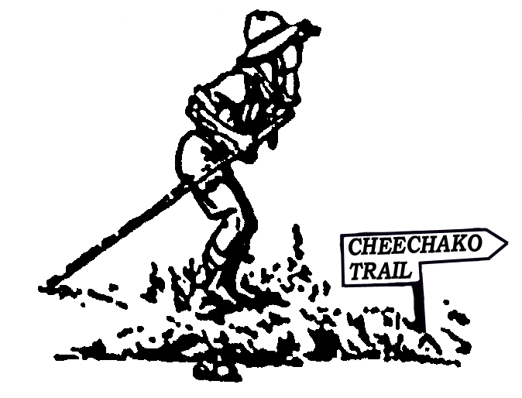

The activities on the Cheechako Trail operate on the same basis as the troop program does year-round. The Scouts will be put into a patrol and assigned a staff member who will work with this "Cheechako Patrol" each morning all week long. They will practice new outdoor skills and then have a grand competition with the other Cheechako Patrols to see how well these new skills have been learned. Maybe they will win a coveted “Gold Medal”.

Each troop will be given a specific time to meet with the Cheechako staff Monday afternoon to tailor-make a program that will best serve the troop. This is especially important to second-year campers that may need only a few requirements offered on the Cheechako Trail to reach their advancement goals. This allows them to work only on the requirements that they need for First Class plus an opportunity to work in the merit badge program.

The staff for this program will sign off the advancement requirements on a special scorecard. Scoutmasters will receive a progress report on the last day of camp. This report consists of a checklist of activities the Scouts worked on during the week that were related to Tenderfoot through First Class requirements. Throughout the week Scoutmasters are encouraged to have conferences with each Scout and the staff to get input on how the program is going.

REQUIREMENTS AVAILABLE ON THE CHEECHAKOTRAIL

TENDERFOOT SECOND CLASS FIRST CLASS
4a 1a 1
4b 1b 2
5 2c 6
9 2d 7a
11 2e 7b
2f 8a
5

MERIT BADGE PROGRAM
The type of program used at Camp Gorsuch is commonly called "Open Programming." This type of program is based on Baden-Powell's concept of Scouts being able to participate in any offered activity or merit badge. The program depends on motivation, both in the boy and from the troop!
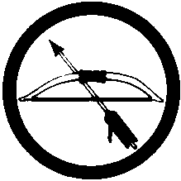




In merit badge counseling, an open program means that the counselor is available to the Scout whenever the program area is open. Scouts should feel free to approach the counselors at any time for guidance on a badge. This type of program minimizes lectures. In other words, there are no scheduled merit badge classes. Group activities, however, will be important to earn some merit badges. For instance, at the waterfront, the rowboats, canoes and sailboats will all leave the dock at particular times - all aboard! The Scout must initially visit with the counselor; discuss the requirements and how to accomplish them at camp. After that the Scout proceeds to complete the requirements on his own. This does not mean that the Scout is to go without instruction or aid. The counselor is always available to help, counsel, and give instruction. What it does mean is, it is the Scout's responsibility to fulfill the badge requirements under the guidance of the counselor. The advantage of this system is that the merit badge counseling is aimed at the individual and not the "class." Using this program, we are able to work with the Scouts to learn and complete the requirement faster than when using the structured merit badge class approach. Open programming is also an advantage in planning your patrol or troop activities. Since there are no merit badge classes, you can schedule activities with greater flexibility. This gives you and your Scouts much more control over your week at camp.

The most helpful "hint" of all is “Be Prepared”. Perhaps you’re ASPL or Troop Librarian could work with your Scouts to obtain and study merit badge books before coming to camp. If the written work and research (books and encyclopedias may help) are done ahead of time, boys can use, to best advantage, opportunities unique to camp (boats, guns, handicraft tools, the lake and woods, etc.).

Some troops have taken advantage of patrol time in their own campsites to work on merit badges begun at home with their own troop counselors. One of the beauties of Scout Camp is that instead of just being together for a single weekly meeting hour, your troop has around 133 hours of time together at summer camp. (Hopefully the Scouts will use some of that time to sleep!) Local troops sometimes use the trip to camp to work on Cycling merit badge.

MERIT BADGE |  | PREREQUISITES |  | COMMENTS
Archery |  |  | Previous practice time |  | For older Scouts. A lot of practice to
 |  |  |  |  | qualify.
Basketry |  |  | None |  | Fun for all!! $8 fee for supplies
BSA Lifeguard |  |  | Age 14 – use the 4 strokes to swim ¼ mile-good form |  | This is a 30-hour course. Need current
 |  |  |  |  | CPR certification to complete.
Camping |  |  |  |  | Requires total of 20 days/nights of camping to complete (Gorsuch counts)
Canoeing |  |  | Must pass “Swimmer” test |  | Difficult for younger Scouts. Must be able to lift and carry canoe
 |  |  |  |  | with a buddy.
 |  |  |  |  | Need extra time to practice strokes.
Climbing |  |  | This merit badge is apart of the Silver Sourdough |  | All climbs and rappels are done on natural rock.
 |  |  | program |  | See pg. 25 for Sourdough details.
Cooking |  |  |  |  | Requires more meal prep. than Scouts will be able to do at camp, but
 |  |  |  |  | menus can be done.
Environmental Science |  |  | Study merit badge book |  | Must work on experiments every day.
 |  |  |  |  | Keep journal on your observations.
Fly Fishing | For older Scouts (limited equip) |  |  |  | Extra time for fishing needed.
Forestry | Study merit badge book |  |  |  | Additional time needed.
Indian Lore |  |  |  |  | $8 fee for supplies
Leatherwork |  |  |  |  | $8 fee for supplies.
Lifesaving | Swimming Merit Badge |  |  |  | For swimmers with strong scissors kick.
Mammals |  |  |  |  | Easiest of Nature Area merit badges. -
 |  |  |  |  | Helpful if requirement #4 is done before camp.
Orienteering | 2nd & 1st Class map and |  |  |  | Much time to set up and run courses.
 | Compass requirements.
Painting |  |  |  |  | This merit badge benefits you & the camp.
Pioneering |  |  |  |  | For all Scouts. Splicing most difficult.
Rifle Shooting |  |  |  |  | Lots of practice time needed to make
 |  |  |  |  | score requirements.
Rowing | Pass “Swimmer” test |  |  |  | For older, stronger Scouts.
Small Boat Sailing | Pass “Swimmer” test |  |  |  | Takes more study than other boating badges.
 |  |  |  |  | Try canoeing or rowing first.
Swimming | Pass “Swimmer” test |  |  |  | Clothes float most difficult. See page
 |  |  |  |  | 12 for additional clothing requirements.

MERIT BADGE | PREREQUISITES | COMMENTS

Wilderness Survival |  | Building fire without matches most
 |  | difficult part. Pray for sun.
Woodcarving |  | $8 fee for supplies. Most difficult and time consuming
 |  | of Handicraft merit badges.

OTHER MERIT BADGE OPPORTUNITIES CONTINGENT UPON TIME AND STAFF:

Fish and Wildlife Management Geology Oceanography

Soil and Water Conservation

MERIT BADGES THAT HAVE SOME REQUIREMENTS THAT CAN BE ACCOMPLISHED AT CAMP:

Bird Study Communications Photography Emergency Preparedness Insect Life

BEAR CLAW AWARD

The Bear Claw Award is a patrol award that Scouts at Camp Gorsuch earn by participating in patrol activities while at camp. A Scout on his own cannot earn this award, but only as a member of a patrol that completes the requirements. It is designed to help a patrol plan and carry out a well-balanced week of Scout activities.

Patrols that complete the Bear Claw requirements will receive a Bear Claw necklace for each member of their patrol. Scoutmasters and Senior Patrol Leaders can also receive a Bear Claw if all their patrols earn the award.

ACTIVITIES

1. Hold a patrol meeting to plan activities for this award, plus if not already done decide on a patrol name, yell, and call.

2. If not already done, design and make a patrol flag.

3. As a patrol do one of the following:
a. Work on a camp service project for at least one hour.
b. Participate with your troop in an outpost camp.
c. Hike one of these camp 5-mile trails:
A. Bear Mountain Trail B. Cheechako Trail C. Sourdough Falls Trail

4. Have a game or contest with another patrol outside your troop.

- Participate in a patrol or troop Friendship Campfire (If there is fire bans in effect have a fellowship with another troop).

6. Participate in a patrol shoot at the archery range or rifle range.

7. Each patrol member makes some type of advancement toward his next rank while at camp. (For example: complete a merit badge or service project).

8. Plan and carry out a patrol activity of the patrol’s choosing.

9. In your campsite, plan and conduct at least one flag raising and one flag lowering ceremony.

SILVER SOURDOUGH

This program is designed for the older Scout or an adult who already has previous years of camping experience. The purpose of the Gorsuch Silver Sourdough program is to provide activities that will challenge the Senior Scout to develop new skills and find new appreciation of the outdoor world.

ELIGIBILITY To participate, a Scout must be:
1. Preparing to enter the 9th grade (or
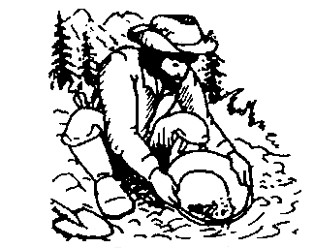
higher) in the fall.
2. 1st Class Rank, or have attended at least 2
years of Boy Scout summer camp.

AWARD REQUIREMENTS
To earn the Silver Sourdough Award, a Scout
must meet the eligibility requirements and
complete at least seven (7) of the activities
below. The three (3) activities marked with
an * are mandatory; at least four (4) more, of
the Scout's choice, must be completed.
Generally, scheduling will be flexible for this program. Details may be arranged through the Program Director or Asst. Program Director. Backpacking equipment is needed for all outpost and overnight camp activities; the camp provides all other equipment.

ACTIVITIES (# Designates new activities)

*1. Mosquito Valley Outpost

*2. Leatherwork Project

*3. One merit badge from the following list:
A. Lifesaving
B. Fish and Wildlife Management
C. Orienteering
D. Small Boat Sailing
E. Soil and Water Conservation
F. Archery
G. Forestry
H. Indian Lore
I. Woodcarving
J. BSA Lifeguard
K. Climbing

4. Paul Bunyan Award

5. Mile Swim

6. Buddy hike

7. Meet or beat camp standard on the
Gorsuch marathon

8. Climb the pole and ring the bell

9. Build a fire by friction

10. Build a coracle and use it

11. Run the camp biathlon

12. Hit 2 of 6 clay pigeons with a shotgun

13. Tie 6 Scout knots in < 30 seconds

14. Additional possibilities may be available

#15. Knik River overnight canoe trip

#16. Low Cope activities

SCOUTMASTER EVENTS

Y'ALL COME: Our Camp Director, Keith Messer, will host a leader's get-together Wednesday morning. This is an opportunity for leaders to share ideas, fellowship, and enjoy a cup of coffee or cocoa. Refreshments will be served!

IN-BETWEEN: Throughout the week, the Scoutmasters have a choice of how they wish to use their time to best advantage.

1) Dan's Palace: With cocoa and coffee always on, this is a place of refuge and a chance to catch up on some of the paper work.

- Special Programs: Many program areas offer activities just for the Scoutmaster during the week. Aquatics run a course in “Safe Swim Defense” and “Safety Afloat” or how about BSA Lifeguard? Also “Climb-on safely” and “Trek Safely” are offered. The Silver Sourdough program encourages adults to participate in its exciting activities.

- Advancement: The adults who come to camp often bring special skills that Scouts might want to learn.

- Service: If you are a carpenter, electrician, plumber, handy-person, or a totem pole carver, camp can sure use your skills during the week. Bring your tools and feel like you're right at home.
PROGRAM PLANNER TROOP_____________ CAMP GORSUCH 2005
Time | MONDAY | TUESDAY |  |  | WEDNESDAY |  | THURSDAY |  | FRIDAY |  | SATURDAY
7:00 |  | REVEILLE |  |  | REVEILLE |  | POLAR BEAR SWIM |  | REVEILLE |  | REVEILLE
7:50 |  | WAITERS REPORT |  |  | WAITERS REPORT |  | WAITERS REPORT |  | WAITERS REPORT |  | WAITERS REPORT
8:00 – 9:00 | 8:30 CAMP OPENS | BREAKFAST |  |  | BREAKFAST |  | BREAKFAST |  | BREAKFAST |  | BREAKFAST
9:00 – 10:00 | ♦LEADERS CHECK IN  ♦MEDICAL RECHECKS  ♦SWIM CHECKS  ♦SET UP CAMPSITES  ♦11:00 a.m. LEADERS’ MTG  at Dan’s Palace | → |  |  | → | → |  | TURN IN REMAINING
10:00 – 11:00 |  | ↓ |  |  | 10:15 Leaders’ Roundtable at Palace |  | ↓ |  | ↓ |  | MERIT BADGE WORK
11:00 – 12:00 |  | ↓ |  |  | ↓ |  | ↓ |  | ↓ |  | PACK UP/CLEAN UP
11:50 | WAITERS REPORT | WAITERS REPORT |  |  | WAITERS REPORT |  | WAITERS REPORT |  | WAITERS REPORT |  | WAITERS REPORT
12:00 – 1:00 | LUNCH | LUNCH |  |  | LUNCH |  | LUNCH |  | LUNCH |  | LUNCH
1:00 – 1:45 | TROOP TIME ‘TIL 2:00 | Adult Safe Swim Defense & Safety Afloat |  |  | Youth Protection  at Dining Hall 1:15pm |  | Climb-on Safely  at Palace 1:15pm |  | Trek Safely  at Palace 1:15pm |  | BE PREPARED RELAY  >> 1– 2pm >>
1:45-2:30 |  |  |  |  |  |  |  |  |  |  | Meet on parade field
2:30 – 3:15 | 2:00 |  |  |  |  |  |  |  |  |  | PACK UP/CLEAN UP
2:30 – 3:15 | 2:00 |  | 3pm Cooking Demo
3:15 – 4:00 | MERIT BADGE | 3pm Sourdough Outpost  meet back of dining hall
 | SIGN-UP |  |  |  |  |  |  |  |  |  | 4pm AWARDS
4:00 – 4:45 |  |  |  |  |  |  |  |  |  |  | CEREMONY
 | 4:30 COMMISSARY |  |  |  |  |  |  |  |  |  | 
5:00 – 6:00 | GEAR CHECK-OUT | Food pickup 5pm  at commissary |  |  | Food pickup 5pm  at commissary |  | Food pickup 5pm  at commissary |  | Food pickup 5pm  at commissary |  | 5pm DINNER AT  DAN’S PALACE
5:00 – 6:00 | WAITERS 5:50
6:00 – 7:00 | DINING HALL  DINNER | CAMPSITE DINNER |  |  | CAMPSITE DINNER |  | CAMPSITE DINNER |  | CAMPSITE DINNER |  | 5:45pm VIDEO SHOW
 |  |  |  |  |  |  |  |  |  |  |  CLOSING 
7:00 – 8:00 | ROUNDTABLE 7pm | Evening Flag |  |  | Evening Flag |  | Evening Flag |  | COMMISSARY  GEAR CHECK-IN |  |  CAMPFIRE   6:15 – 7:45pm
7:00 – 8:00 | ROUNDTABLE 7pm | 7:30 |  |  | 7:30 |  | 7:30 VESPERS |  |  |  |  CAMPFIRE   6:15 – 7:45pm
8:00 – 9:00 |  |  |  |  | Patrol Challenge |  |  |  |  |  | HAVE A SAFE
8:00 – 9:00 |  CAMPFIRE  |  |  |  |  |  |  |  |  |  | HAVE A SAFE
9:00 – 10:00 | AT 8:30pm   |  |  |  | OA Fellowship |  |  |  |  |  | TRIP HOME!
10:00 | TAPS | TAPS |  |  | TAPS |  | TAPS |  | TAPS

GORSUCH 2005

TROOP # CAMPSITE WEEK OF

ADULTS: CAMP SCOUTMASTER

2. |  | 3.
4. |  | 5.
SENIOR PATROL LEADER __

 |  | PATROL NAME
 | 1 | PL:
 | 2
 | 3
 | 4
 | 5
 | 6
 | 7
 | 8
 | 9

 |  | PATROL NAME
 | 1 | PL:
 | 2
 | 3
 | 4
 | 5
 | 6
 | 7
 | 8
 | 9

 |  | PATROL NAME
 | 1 | PL:
 | 2
 | 3
 | 4
 | 5
 | 6
 | 7
 | 8
 | 9

 |  | PATROL NAME
 | 1 | PL:
 | 2
 | 3
 | 4
 | 5
 | 6
 | 7
 | 8
 | 9

BIKING

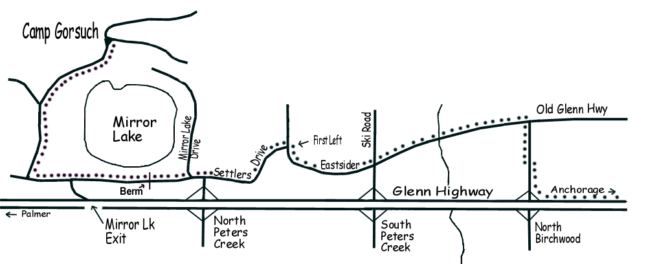
BIKERS! How about your Troop or Patrol coming to camp on bikes. By following the bike trail to where it ends at Ski Road then following the map, you can ride to Camp Gorsuch without having to use busy highways. Special arrangements can be made for bikers who wish to come to camp Sunday afternoon.
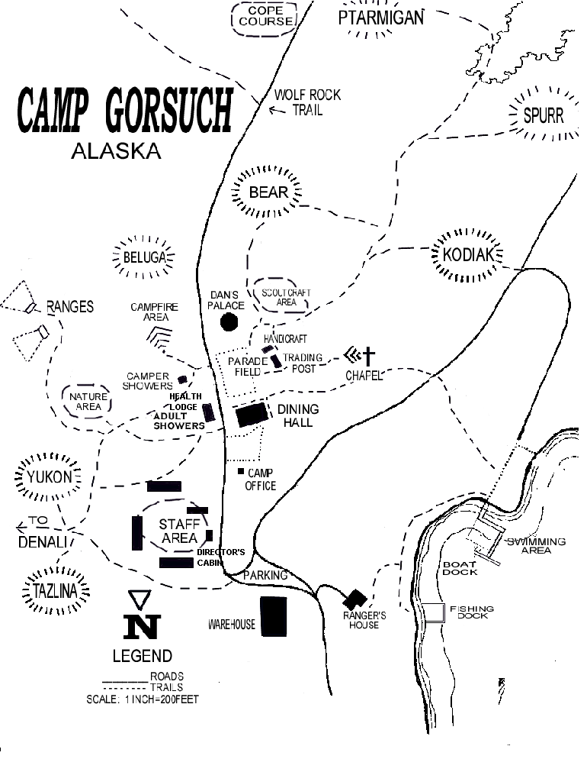

Camp Gorsuch Leader’s Guide

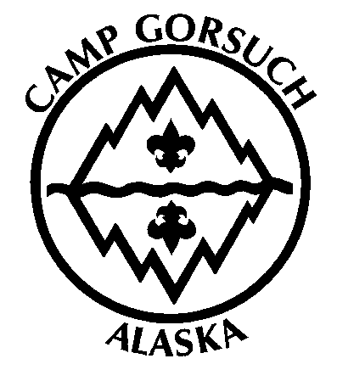

ADDENDUM

This information is designed to supplement and replace information distributed with the 2006 Camp Gorsuch Leader’s Guide. The leadership of Camp Gorsuch is continually updating its program to meet the needs of its scouts, and this information will help communicate certain changes in this year’s program.

Keith Messer
Camp Director
(907) 337-9547
sthill@bsamail.org

I. Adult Work Party

Reminder: On May 14th we will have a council-wide work party at Camp Gorsuch. There's a lot to do so put on your work clothes and gloves and spend the day with your Scouter friends fixing what needs fixing and building what needs built. Lunch will be provided, so y'all come! Be there. This is the only way we can get camp ready.

II. Camp Leader Orientation Meeting

Reminder: There will be a camp leader orientation meeting on Tuesday, June 6th at 6:30 PM at Camp Gorsuch. This orientation will prepare you for a successful camp. You may also pick up your free camp T-shirts. It is important that all local troops have a representative at this meeting.

III. Handicraft Fees

A discrepancy in the leaders’ guide left the cost of handicraft supplies a little fuzzy. This year, each handicraft merit badge requiring supplies will cost $8.

IV. Trading Post

This year, we are expanding the selection in the trading post to include more Camp Gorsuch memorabilia than in the past. These souvenirs will serve to remind you of the great time you had at camp! Remember to bring sufficient money to purchase anything that strikes your fancy.

V. BSA Lifeguard

Scouts and Scouters working to earn their BSA Lifeguard will have an opportunity to do so at Camp. However, their certification is not valid unless the scout has also been formally trained in CPR by the American Red Cross, American Heart Association, or the National Safety Council. Securing this training prior to camp will ensure that the scout is able to complete the BSA Lifeguard certification at camp.

VII. Merit Badge Applications

This year, unlike in years past, Camp Gorsuch will use the official BSA Merit Badge Applications (also known as “Blue Cards”). Use of the three-section perforated blue card will ensure that multiple records are on file for completed merit badges, and that ‘partials’ received at camp can be continued at a later date. Please make sure that each scout arrives the first day of each merit badge session with a Blue Card, SIGNED by the Scoutmaster in the appropriate place (the application side), and filled out with the scout’s personal information.

VIII. Fly Fishing

Fly Fishing will no longer be included on this year’s schedule as a merit badge offered.

IX. Quartermaster

This year, we are providing, as a service to your troop, a Camp Quartermaster! For the first time, your troop has a central location to receive materials such as rakes, shovels, toilet paper, latrine cleaner, and other necessary camp supplies. Find him in the Commissary! We hope you enjoy this service provided to you and find it a convenient and helpful addition to our camp.

X. Silver Sourdough

2006 will mark the year that we expand the Silver Sourdough high adventure program! This year we are including more high-adventure related activities, opening the low-COPE course, and even offering a canoe trip down the Knik River! The surprises awaiting you in the Silver Sourdough program are endless. If you expect to participate, you are in for a treat. It is a program unlike any that has been offered at Camp Gorsuch before.

XI. Cheechako Trail

This year, we are expanding our Cheechako Trail program. We have completely changed the previous method of teaching our first-year camper program, and instead have adopted a new program designed to allow for a more flexible and more efficient program. The following pages will explain in detail how the new program works.


A new makeover is being given to Cheechako Trail, Camp Gorsuch’s program for first-year campers. This program is designed to allow younger scouts to achieve rank advancement their first year at summer camp, and to prepare them for future years at camp earning merit badges.

Rank advancement skills (Tenderfoot through First Class) will be taught each morning of camp at Dan’s Palace. The schedule of when each skill is being taught is included here, as well as posted in Dan’s Palace. This allows a scout to attend those sessions needed for advancement, and spend time elsewhere in camp during skills which he has already mastered. Most skills will not be signed off at this time, only taught.

The scout must return in the afternoon (later that day or week) to show the instructors that he has successfully mastered that skill. The purpose of this process is two-fold: it ensures that the scout has remembered how to perform a skill for at least a day (not memorizing it only for a few minutes), and it allows Cheechakos to build a flexible camp schedule. A scout who has already earned all of the first aid requirements for rank advancement may decide to go on a nature hike with his troop instead of participating in Cheechako Trail that day.

This new process allows Cheechakos to learn approximately 50% more skills than in years past, allows for more personal attention to be paid to scouts by staff members, and reinforces skills over a period of time. Scouts wishing to attend the overnight campout must bring a tent and other appropriate camping gear.

Adult leaders are strongly encouraged to spend part of a morning or all day in Cheechako Trail. The more leaders, the better! At the end of the week, Scoutmasters will be provided with sign-off forms for each Cheechako, indicating those skills which were satisfactorily shown to the instructor. Nothing is signed off in the BSA handbook! The Scoutmaster may wish to review skills back in the campsite or at home before signing the book.

 | Monday | Tuesday | Wednesday | Thursday | Friday | Saturday
9 - 10am | Troop Check-in, Health Rechecks, Orientation, Swim Checks, 11am Leader's Meeting at Dan's Palace | Totin' Chip and Woods Tools (2-2c) | Physical Fitness (T-9) | Whip/Fuse Rope (T-3a) | Heimlich Maneuver (T-11a) | Flags (T-5)
9 - 10am |  | Poisonous Plants (T-10) | Physical Fitness (T-9) | Hitches (T-3b) | Heimlich Maneuver (T-11a) | Flags (T-5)
9 - 10am |  | Lost (T-4) | Physical Fitness (T-9) | Packing (T-1) | First Aid (T-11b) | Hiking Rules (T-4)
9 - 10am |  | Buddy System (T-9)
10 - 11am |  | Wild Animals (2-5) | Woods Tools (2-2c) | Hitches/Lashings (1-7a/b) | Hurry Cases (2-6a) | 5-mile Hike (2-1b)
10 - 11am |  | Map & Compass (2-1a) | Preparing Firewood (2-2d) | Hitches/Lashings (1-7a/b) | First Aid Kit (2-6b) | 5-mile Hike (2-1b)
10 - 11am |  | Height and Width (1-2) | Fire vs. Stove Safety (2-2e) | Hitches/Lashings (1-7a/b) | First Aid (2-6c) | 5-mile Hike (2-1b)
10 - 11am |  | Height and Width (1-2) | Fire building & Stove (2-2f) | Hitches/Lashings (1-7a/b) | First Aid (2-6c) | 5-mile Hike (2-1b)
11 am - Noon |  | Directions-Day/Night (1-1) | Plan Menu (1-4a) | Hitches/Lashings (1-7a/b) | Bandages (1-8b) | 5-mile Hike (2-1b)
11 am - Noon |  | Trees/Shrubs (1-6) | Food List (1-4b) | Hitches/Lashings (1-7a/b) | Transport (1-8c) | 5-mile Hike (2-1b)
11 am - Noon |  | Bowline (1-8a) | Cooking Gear (1-4c) | Camp Gadget (1-7c) | Heart Attack/CPR (1-8d) | 5-mile Hike (2-1b)
11 am - Noon |  | Bowline (1-8a) | Safe Handling and Storage (1-4d) | Camp Gadget (1-7c) | Heart Attack/CPR (1-8d) | 5-mile Hike (2-1b)
Noon - 2pm | Lunch | Lunch | Lunch | Lunch | Lunch | Lunch and Be Prepared Relay
2 - 3pm | Cheechako Orientation and Sign-Up in Dan's Palace | Rank Swim (2-a-c) (1-a-d) OR Merit Badge OR Skill Sign-Off | --> | --> | --> | Clean/Pack-up Camp
3 - 4pm | Cheechako Orientation and Sign-Up in Dan's Palace | Merit Badge OR Skill Sign-Off OR Free Time | --> | --> | --> | Clean/Pack-up Camp
4 - 5pm | Commisary Gear Pick-up (4:30) | Merit Badge OR Skill Sign-Off OR Troop Activity | --> | --> | --> | Awards Ceremony at Dan's Palace
After Supper | Opening Campfire (8:30pm) |  | Patrol Challenge | Vespers | Cheechako Overnighter | Closing Campfire (6:15pm)

